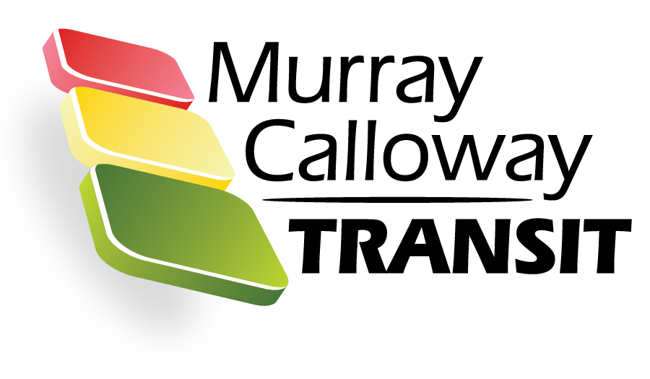

**Murray Calloway Transit Authority**

ADA Complaint Procedures and Form

Accommodations are made to serve persons with disabilities in compliance with the Americans with Disabilities Act (ADA) and Section 504. Section 504 of the Rehabilitation Act of 1973 (Section 504), Titles II and III of the Americans with Disabilities Act of 1990 (ADA) and related Federal and State Laws and Regulations provide that no entity shall discriminate against an individual with a disability in connection with the provision of transportation service. This law requires federal aid recipients and other government entities to take affirmative steps to reasonably accommodate the disabled and ensure that their needs are equitably represented.

The Murray Calloway Transit Authority (MCTA) endeavors to ensure that its facilities, programs and services are available to those with disabilities in accordance with the Americans with Disabilities Act (ADA). If you feel that your ADA protection has been violated, you may file a complaint with MCTA’s ADA coordinator. The following information is necessary to assist us in processing your complaint. If you require any assistance in completing this form, please contact MCTA ADA Coordinator David McLeod at [murraytransittraining@gmail.com](mailto:murraytransittraining@gmail.com%20) or call (270) 753- 9725. The completed form must be returned to the Murray Calloway Transit Authority (MCTA), 1111 Transit Way, Murray, Kentucky 42071.

The complaint procedure will be made available to the public at [www.murraytransit.com.](http://www.murraytransit.com.)

A copy of the complaint form in English and Spanish is provided in MCTA’s Title VI Plan and on the Transit’s website.

Complaint Form

**Murray Calloway Transit Authority (MCTA)**

ADA Complaint Form

|  |  |  |  |  |  |  |  |  |  |
| --- | --- | --- | --- | --- | --- | --- | --- | --- | --- |
| **Section I:** | | | | | | | | | |
| **Name:** | | | | | | | | | |
| **Address:** | | | | | | | | | |
| **Telephone (Home):** | | | **Telephone (Work):** | | | | | | |
| Electronic Mail Address: | | | | | | | | | |
| Accessible Format Requirements? | Large Print |  | | | **Audio Tape** | | | |  |
| TDD |  | | | **Other** | | | |  |
| **Section II:** | | | | | | | | | |
| Are you filing this complaint on your own behalf? | | | | | | Yes* | No | | |
| *If you answered "yes" to this question, go to Section III. | | | | | | | | | |
| If not, please supply the name and relationship of the person for whom you are complaining: | | | | | |  | | | |
| Please explain why you have filed for a third party: | | | |  | | | | | |
|  | | | | | |
| Please confirm that you have obtained the permission of the aggrieved party if you are filing on behalf of a third party. | | | | | | Yes | | No | |
| **Section III:** | | | | | | | | | |
| I believe the discrimination I experienced was based on (check all that apply):  [ ] Race [ ] Color [ ] National Origin [ ] Age  [ ] Disability [ ] Family or Religious Status [ ] Other (explain) Date of Alleged Discrimination (Month, Day, Year):  Explain as clearly as possible what happened and why you believe you were discriminated against. Describe all persons who were involved. Include the name and contact information of the person(s) who discriminated against you (if known) as well as names and contact information of any witnesses. If more space is needed, please use the back of this form. | | | | | | | | | |
| **Section IV** | | | | | | | | | |

|  |  |  |
| --- | --- | --- |
| Have you previously filed a Title VI complaint with this agency? | Yes | No |

|  |
| --- |
| **Section V** |
| Have you filed this complaint with any other Federal, State, or local agency, or with any Federal or State court? [ ] Yes [ ] No  If yes, check all that apply:  [ ] Federal Agency:  [ ] Federal Court [ ] State Agency [ ] State Court [ ] Local Agency |
| Please provide information about a contact person at the agency/court where the complaint was filed. |
| **Name:** |
| **Title:** |
| **Agency:** |
| **Address:** |
| **Telephone:** |
| **Section VI** |
| Name of agency complaint is against: |
| Contact person: |
| Title: |
| Telephone number: |

You may attach any written materials or other information that you think is relevant to your complaint. Signature and date required below

Signature Date

MCTA operates its programs without regard to race, color or national origin. To request information or to file a discrimination complaint, contact:

Please submit this form in person at the address below, or mail this form to:

David McLeod, Supervisor

Murray Calloway Transit Authority

1111 Transit Way

Murray, Kentucky 42071

MCTA opera sus programas sin distinción de raza, color u origen nacional. Para solicitar información o presentar una queja por discriminación, contacte a:

Envíe este formulario en persona a la dirección que figura a continuación, o envíe este formulario a:

David McLeod, Supervisor

Autoridad de tránsito de Murray Calloway

Camino de tránsito 1111

Murray, Kentucky 42071

|  |  |  |  |  |  |  |  |  |  |
| --- | --- | --- | --- | --- | --- | --- | --- | --- | --- |
| **Sección I:** | | | | | | | | | |
| **Nombre:** | | | | | | | | | |
| **Dirección:** | | | | | | | | | |
| **Teléfono (Hogar):** | | | **Teléfono (Trabajo):** | | | | | | |
| Dirección de correo electrónico: | | | | | | | | | |
| ¿Requisitos de formato accesible? | Impresión grande |  | | | **Cinta de audio** | | | |  |
| Tdd |  | | | **Otro** | | | |  |
| **Sección II:** | | | | | | | | | |
| ¿Está presentando esta queja en su propio nombre? | | | | | | Sí* | No | | |
| *Si respondió "sí" a esta pregunta, vaya a la Sección III. | | | | | | | | | |
| Si no es así, proporcione el nombre y la relación de la persona por la que se queja: | | | | | |  | | | |
| Por favor, explique por qué ha presentado una solicitud para un tercero: | | | |  | | | | | |
|  | | | | | |
| Confirme que ha obtenido el permiso de la parte agraviada si está presentando en nombre de un tercero. | | | | | | Sí | | No | |
| **Sección III:** | | | | | | | | | |
| Creo que la discriminación que experimenté se basó en (marque todo lo que corresponda):  [ ] Raza [ ] Color [ ] Origen nacional [ ] Edad  [ ] Discapacidad [ ] Estado familiar o religioso [ ] Otro (explique)  Fecha de supuesta discriminación (mes, día, año): Explica lo más claramente posible lo que sucedió y por qué crees que fuiste  discriminado. Describa a todas las personas que participaron. Incluya el nombre y la información de contacto de la(s) persona(s) que le discriminaron (si se conocen), así como los nombres y la información de contacto de cualquier testigo. Si se necesita más espacio, utilice la parte posterior de este formulario. | | | | | | | | | |

|  |  |  |
| --- | --- | --- |
|  | | |
| **Sección IV** | | |
| ¿Ha presentado previamente una queja del Título VI ante esta agencia? | Sí | No |

|  |
| --- |
| **Sección V** |
| ¿Ha presentado esta queja ante cualquier otra agencia federal, estatal o local, o ante algún tribunal federal o estatal?  [ ] Sí [ ] No  En caso afirmativo, marque todas las que correspondan: [ ] Agencia Federal:  [ ] Tribunal Federal [ ] Agencia Estatal  [ ] Tribunal del Estado [ ] Agencia Local |
| Proporcione información sobre una persona de contacto en la agencia/tribunal donde se presentó la queja. |
| **Nombre: David McLeod** |
| **Título: Supervisor** |
| **Agencia: Autoridad de transito de Murray Calloway** |
| **Dirección: 1111 Transit Way, Murray , KY 42071** |
| **Teléfono: 270-753-9725** |
| **Sección VI** |
| El nombre de la queja de la agencia está en contra de: |
| Persona de contacto: David McLeod |
| Título: Supervisor |
| Número de teléfono: 270-753-9725 |

Puede adjuntar cualquier material escrito u otra información que considere relevante para su queja.

Firma y fecha requeridas a continuación

Fecha de firma

Por favor envíe este formulario en persona a la siguiente dirección, o envíe lo presente por correo a:

Atención: David McLeod, Gerente de Derechos Civiles para Programas OTD / FTA

Autoridad de tránsito de Murray Calloway 1111 Transit Way,

Murray, Kentucky 42071